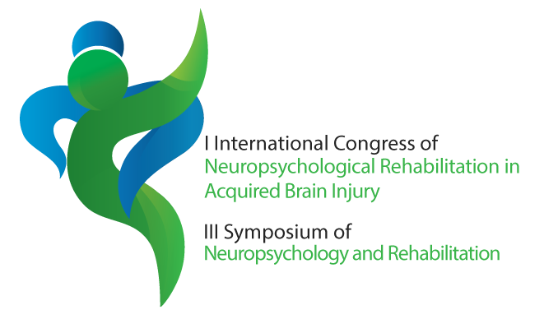


Rules for the abstracts:
- The abstracts must be written in English and the text should be typed in font Arial, 11-point using double spacing.
- The name of presenting author shall be in bold and underline.
- The abstract must contain the sections headed in this template (Introduction; Objectives; Materials and Methods; Results and Discussion; Conclusion and References). The Acknowledgments are optional.
- The abstracts will only be considered and included in the Proceedings Book if the presenting author is registered.
- The registration of each presenting author allows submitting up to three abstracts (whether oral communication or poster).
- The abstracts shall be submitted only online.
- For more information, please send an e-mail to the Scientific Committee (ic.abi@estsp.ipp.pt).

Presentation Preference (please tick one):
Oral presentation
Poster presentation
The Scientific Committee reserves the right to suggest a different format of the selected by authors.

